1-wire temperature sensor App Notes

Dallas Semiconductor Corp. worked out a communication bus system for simple sensors and other equipments called 1-wire protocol. This protocol provides low-speed data exchange, signaling and power over single signal wire. It is possible to connect up to 75 devices to one bus, forming MicroLan networks. MicroLan networks have one master unit, what controls network's traffic and ensures that one device at a time uses the bus. 1-wire protocol is similar to I2C protocol, but has lower data rates, longer distance range and only one wire for all communication.

1-wire communication is mostly used for communicating between different sensors and memory units. Bus data transfer rate is approximately 16.3 kbit/s. Communication is started by a master with the “reset” pulse, which pulls the wire to 0 volts for at least 480 µs. This signal resets all devices on the bus, simply taking the power out from the bus. After that, any device on the bus, shows that it exists with a “presence” pulse by holding the wire to ground at least 60 µs after the master releases the bus. With following 8-bit command and then data can be sent or received in groups of 8-bits. Each device on the bus has a unique 64-bit serial identification number.

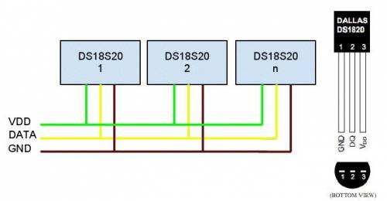

To find all devices, master send an enumeration command, and an address. For each bit master listens the answer. If slave device has all right address bits it returns a 0. Master uses this simple behavior to search for valid sequences of address bits. An enumeration of 10 or 15 devices finishes very quickly.

A read-time is initiated by master device pulling the 1-wire bus low for a minimum of 1 µs and then releasing the bus. Slave device transmits a 1 by leaving the bus high and transmits a 0 by pulling the bus low.

When transmitting a 0, slave device releases the bus by the end of the time, and the bus will be pulled back to its high idle state by pull-up resistor. Output data from the slave is valid for 15 µs after the falling edge which initiated read-time.

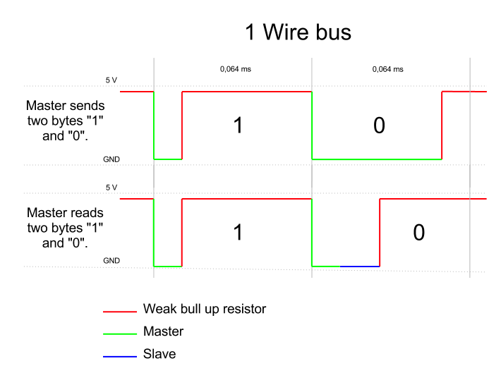

The DS18S20 digital thermometer provides 9–bit centigrade temperature measurements and has an alarm function with nonvolatile user-programmable upper and lower trigger points. A digital thermometer DS18S20 with a 1-wire communication protocol can be connected with Robotic HomeLab Sensor module external sensor connectors. Sensors's technical properties are following:

* Power supply: +3…+5 VDC
* Temperature measurement range: -55…+100 °C
* Wire length: 2 m
* Datasheet [Link](http://www.mmajunke.de/ds1820.pdf)

In the example below, 1-wire temperature sensor takes measurements and displays the results on HomeLab's User Interface board LCD display. With the present configuration and provided example code only 5 sensors can be connected to one bus. Sensors will be found automatically.

1-wire temperature sensor must be connected to sensor board ADC3 pin group. After loading the example program to the controller appears sensors queue number and temperature in Celsius on the User Interface board LCD display. If more than one sensor are connected on the bus, then sensor measurements are displayed in a row. Sensor and power supply type are also displayed. Homelab sensor's type is DS18S20 and power supply type is “externally”. It's possible to connect sensor only with 2 wires, in that case sensor receives it's power supply from data bus and on display “parasite” is displayed. “ERROR!” is shown in the display if error occurs, in this case the problem is most likely related with wiring.

Colors of the wires for connecting the sensor:

* Green - Optional VDD pin. VDD must be grounded for operation in parasite power mode
* White - Data Input/Output pin. Open-drain 1-wire interface pin. Also provides power to the device when used in parasite power mode.
* Brown - Ground.

Example code enabling to read the temperature with 1-wire protocol is shown below. It is important to include “onewire.h” and “onewire.c” to the program. Sensor-specific code is located in “ds18x20.h” and “ds18x20.c” files. Link is below:

https://home.roboticlab.eu/en/examples/sensor/1-wire